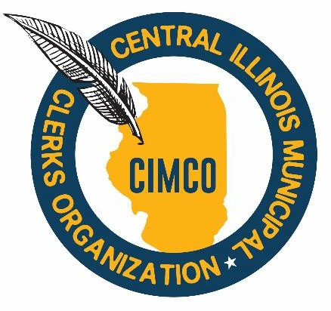

From: Nicole Stewart, President

To: CIMCO Members

Subject: December Meeting Notice

Attachments: February 12, 2025, Agenda

December 11, 2024 Minutes

Treasurer’s Quarterly Report (October – December 2024)

Hello CIMCO Members,

Join us for our next regular meeting on **Wednesday, February 12, 2025 at 12:00 P.M. at Pekin City Hall, 111 South Capitol Street, Pekin, Illinois**. Sue McMillan and I will be your hosts. Our guest speaker this month is Bob Grogran, a City of Pekin consultant and President of Middle America Government Consulting. He will present “Clerk Bootcamp: From Chaos to Clarity – Rules, Fraud and Transparency”. This program will explore Robert’s Rules, emerging fraud trends and government transparency.

Lunch will be provided by the City of Pekin catered by BC BBQ.

Parking Information:

* Street parking is available on **Capitol and Sabella Streets.**
* Additional parking is available in the **lot across from the Police Department/City Hall** at the corner of Capitol and Sabella.
* If entering via the **Police Department entrance on Sabella**, take the elevator or stairs to the second-floor lobby.
* If entering from **Capitol Street**, you will arrive directly in the lobby.
* The **Council Chambers** is located off the lobby near the front entrance.

I look forward to seeing you all next week for a great meeting!

Meeting Details:

Date: Wednesday, February 12, 2025

Time: 12:00 P.M.

Place: City of Pekin, City Hall Municipal Building

Address: 111 S. Capitol Street, 2nd Floor Council Chambers, Pekin, IL 6155

RSVP: Please RSVP to Tammy Hintz at [thintz@delavanil.org](mailto:thintz@delavanil.org) no later than Monday, February 10, 2025 if you plan to attend.