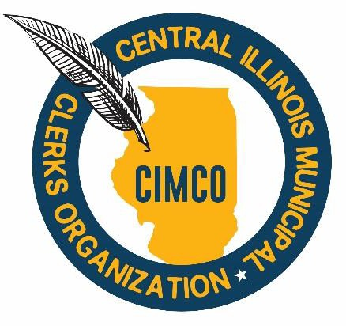

From: Nicole Stewart, President

To: CIMCO Members

Subject: April Meeting Notice

Attachments: April 8, 2026, Agenda
February 11, 2026 Minutes

Hello CIMCO Members,

Our next meeting is scheduled for Wednesday, April 8, 2026, at 12:00 PM at the Town of Normal, located at 11 Uptown Circle, 3rd Floor, Ron Hill Conference Room, Normal, IL 61761. Angie Huonker and her team will be our hosts. They will be presenting on DOJ ADA Compliance.

Lunch will be provided by the Town of Normal.

Parking Information:

Parking is available in the attached parking deck – Parking vouchers will be provided; however attendees will need to start a parking session upon arrival by scanning the QR Code on posted signage in the deck or texting Park to 30843. Attendees will need to enter their vehicle information when starting their parking session.

I look forward to seeing you all in April for an exciting meeting!

Meeting Details:
Date: Wednesday, April 8, 2026
Time: 12:00 P.M.
Place: Town of Normal, Ron Hill Conference Room
Address: 11 Uptown Circle, 3rd Floor, Normal, IL 61761
RSVP: Please RSVP to Tammy Hintz at thintz@delavanil.org no later than Monday, April 6, 2026 if you plan to attend.

